14.05 Virtual Lecture Notes (Part 2)
Through some simple experimentation, you have discovered that Java permits instance variables and local variables to have the same name, but the results are not what you might expect. Reexamining the code will clear things up.

When the code is compiled, Java evaluates which name variable should be used for which purpose. In effect, it is trying to determine whether to use this one or that one, as illustrated below.

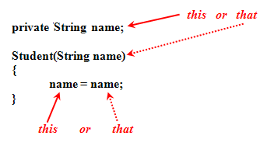 | The compiler resolves this ambiguous situation by using the most locally defined variable, in this case the constructor’s parameter.  Consequently, the statement name = name simply results in the object stored in the local parameter variable (i.e., that one) being reassigned to itself!  Therefore, the instance variable (i.e., that one) never gets assigned anything, so its initial value remains null.

Before you decide that prefixed variable names are the only way out of this dilemma, let’s make a minor modification to the code, as shown below.

private String name;  Student(String name)  {  this.name = name;  } | private String name;  public void setName(String name)  {  this.name = name;  }
This minor change resolves the confusion between whether we are referring to the private instance variable (i.e., this one) or the local parameter variable (i.e., that one).

- Open and compile the ThisDemo1cTester class.
- Examine the source code and notice the use of the keyword this.
- Can you predict what will be printed?
- Run the program and observe the results.

Notice that this is used to assign the local variable to the private instance variable, but not in its declaration. Make a similar modification for the ThisDemo2cTester class.

So, how do you interpret this.name in these examples? The keyword this is a way to refer to the object of the class within the class definition.

